ST. MATTHEW’S 2019 SUMMER CAMP
Camp Discovery: Discovering Adventure
160 Fairview Road & Lukens Ave.
St. Matthews Evangelical Lutheran Church: P.O. Box 55, Woodlyn, PA. 19094

https://stmatthewwoodlynforkids.weebly.com/
610-833-5518
Registration Form – June 17 – August 9, 2019
Child’s Name: ____________________________
Age/Birthday: __________ School: ___________
Address: _________________________________
Parent(s) / Guardian:_______________________
Work phone #: ___________________________
Home#:______________Cell#:_____________
Emergency Contact(s):_____________________
Camp: June 17 – August 9, 2019: 9am – 5pm
- Half days/ early drop- off available (See following pages for more information)

Emergency and Health Information
Child’s name: __________________________
What should we know about the health of your child?
Allergies (Including reactions to medications):_________________________
Dietary Concerns: _________________________
Physical Challenges: _________________________
Learning Challenges: _________________________
Name of child’s physician and health coverage: ______________________________ ________________________________________________________________________
Who should pick up your child?
Name: __________________________
Relationship to child: ___________________________
Daytime telephone #: ___________________________
Name: ___________________________
Relationship to child: ___________________________
Daytime telephone #: ____________________________
Who should not pick up your child?
Name(s): ____________________________
Relationship to child: ____________________________
________________________________________________________________
Parental Signature of consent: ______________________________________

Permission given to:
________ Obtain emergency medical care
________ Take walks and field trips
________ Administer minor first aid procedures
________ participate in outdoor and water activities

Tuition Information:
Registration Fee: $75.00 Nonrefundable Due by June 15th, 2018. (Please call for any questions)
1. Open enrollment will be accepted throughout the 8 weeks
2. Siblings receive a 10% discount
Early drop-0ff: 8:00am – 9:00am
- $5.00 a day (10% discount for siblings) - from 8:00am – 9:00am: Includes a snack, and fun center based activities for your child to participate in.
Full Day program: 9am – 5pm
8 week summer camp program cost: $825.00 from 9am – 5pm ($175.00 savings from the weekly plan cost)
- Can pay in full, or 3 payments of $275.00 due by: June 22, July 20, August 10
Weekly plan cost: $125.00 per week OR $25.00 per day from 9am – 5pm (Choose your own weeks) – Please contact us if you have any questions or concerns.
Half day program: 9am – 1pm, or 1pm – 5pm
8 week summer camp program cost: $400.00 from 9am – 1pm, or 1pm – 5pm ($100.00 savings from the weekly plan cost)
- Can pay in full, or 3 payments of $133.33 due by: June 22, July 22, August 10
Weekly plan cost: $62.50 per week OR $12.50 per day from 9am – 1pm, or 1pm – 5pm (Choose your own weeks)
-Please contact us if you have any questions or concerns.
- Payments include entrance to all field trips and snacks.
Field trips:
1. Safari Party Animal Show
2. Woodlyn Post office
3. Additional field trips will be planned based on the number of children.
Lunch: we ask you please pack a lunch for your child. Sandwiches will be provided in case child does not have lunch. We will have weekly lunch fun days on Friday which will be provided. Daily snack will be provided.

- If possible, children will need a swim suit for water activities, and a sleeping bag, or blanket if your child will take a nap in the afternoon.
- All activities will be modified to meet your child’s needs.
- All children must be signed in and out by parent/guardian.

For any additional questions or concerns please call 610-833-5518. Below is a description of the type of activities your child will partake in, as well as our daily schedule and weekly themes.

Description:
Thank you for enrolling your child to St. Matthew’s summer camp program. Our eight week summer program will include a variety of activities that will allow your children to learn at their own pace through art, music, movement, while expressing their imagination and creativity in a welcoming child centered environment. Our planned activities will focus on the theme Camp Discovery: Discovering Adventure. Camp Discovery will allow your child to go on an adventure to discover the world around them, and use their creativity and imaginations. We will go on a fun adventure that will take us to space, the ocean, as well as traveling back in time. We will travel the world to learn about what makes everyone special through our fun themes. We will conduct hands on experiments, and have fun learning with popular story book characters.
We will give your child many opportunities to practice their reading and writing skills, as well as for younger children (Pre K) to practice their fine motor skills (grasping writing tools, scissors, etc.), along with activities that will help them to recognize their name, letters, shapes, numbers, and colors. We will provide many outdoor activities: walks, free play at the playground, and water play with sprinkler and camp pool. Additionally, we will go on fun adventures with special guests from our community, and enjoy special events. We are excited to meet you and your children this summer, and plan on having a lot of fun!
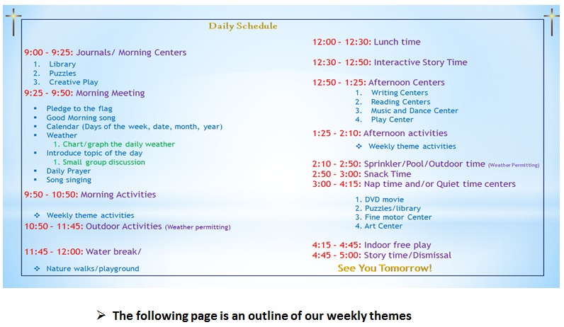
Daily Schedule:
